GraphRAG Research Exploration and Taxonomy
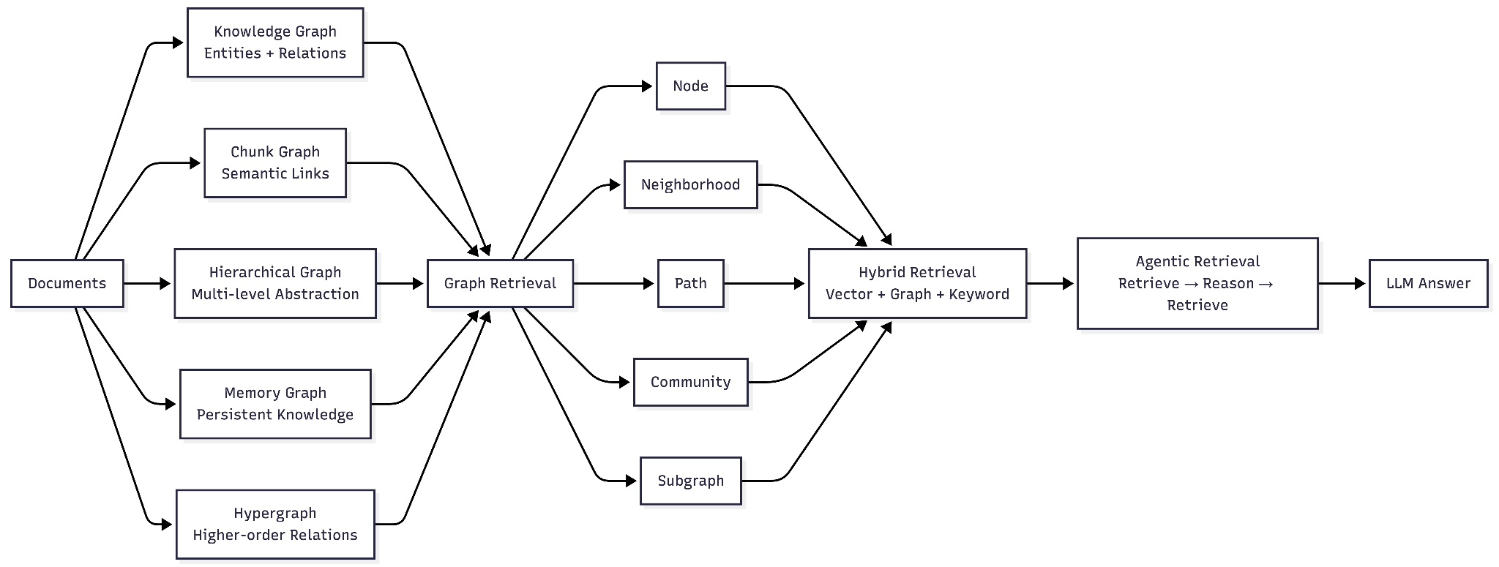
The primary objective of this week's research was to develop a comprehensive understanding of the GraphRAG landscape and identify the major design dimensions that differentiate graph-based retrieval systems from traditional vector-based Retrieval-Augmented Generation (RAG) architectures.
Rather than focusing on a specific implementation, the study aimed to establish a taxonomy of GraphRAG systems by examining how knowledge is represented, constructed, retrieved, and ultimately utilized during the generation process. Through a survey of recent GraphRAG literature and emerging research trends, the field was organized into four major areas of investigation:
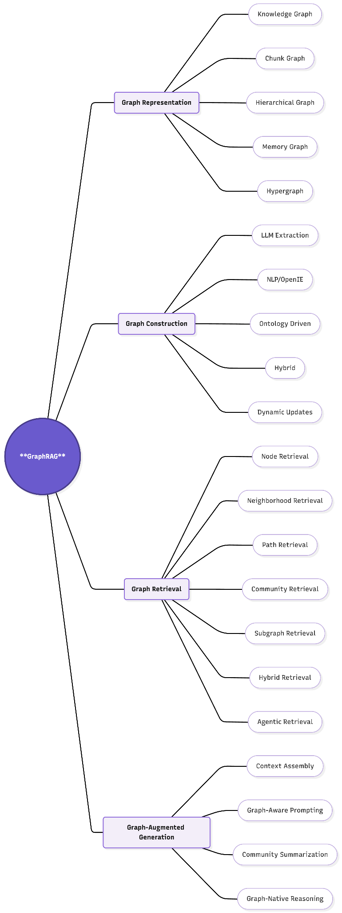

1. Graph Representation
Graph representation focuses on the structure of knowledge within a GraphRAG system and addresses the question: What type of graph should be built from the source documents?
The following graph representation paradigms were explored:
- Knowledge Graphs – Represent entities and explicit relationships between them.
- Chunk Graphs – Model document chunks as nodes connected through semantic similarity or references.
- Hierarchical Graphs – Organize information across multiple abstraction levels such as Domain → Topic → Document → Chunk.
- Memory Graphs – Capture associative and persistent knowledge structures inspired by memory systems.
- Hypergraphs – Represent higher-order relationships involving multiple entities simultaneously through hyperedges.
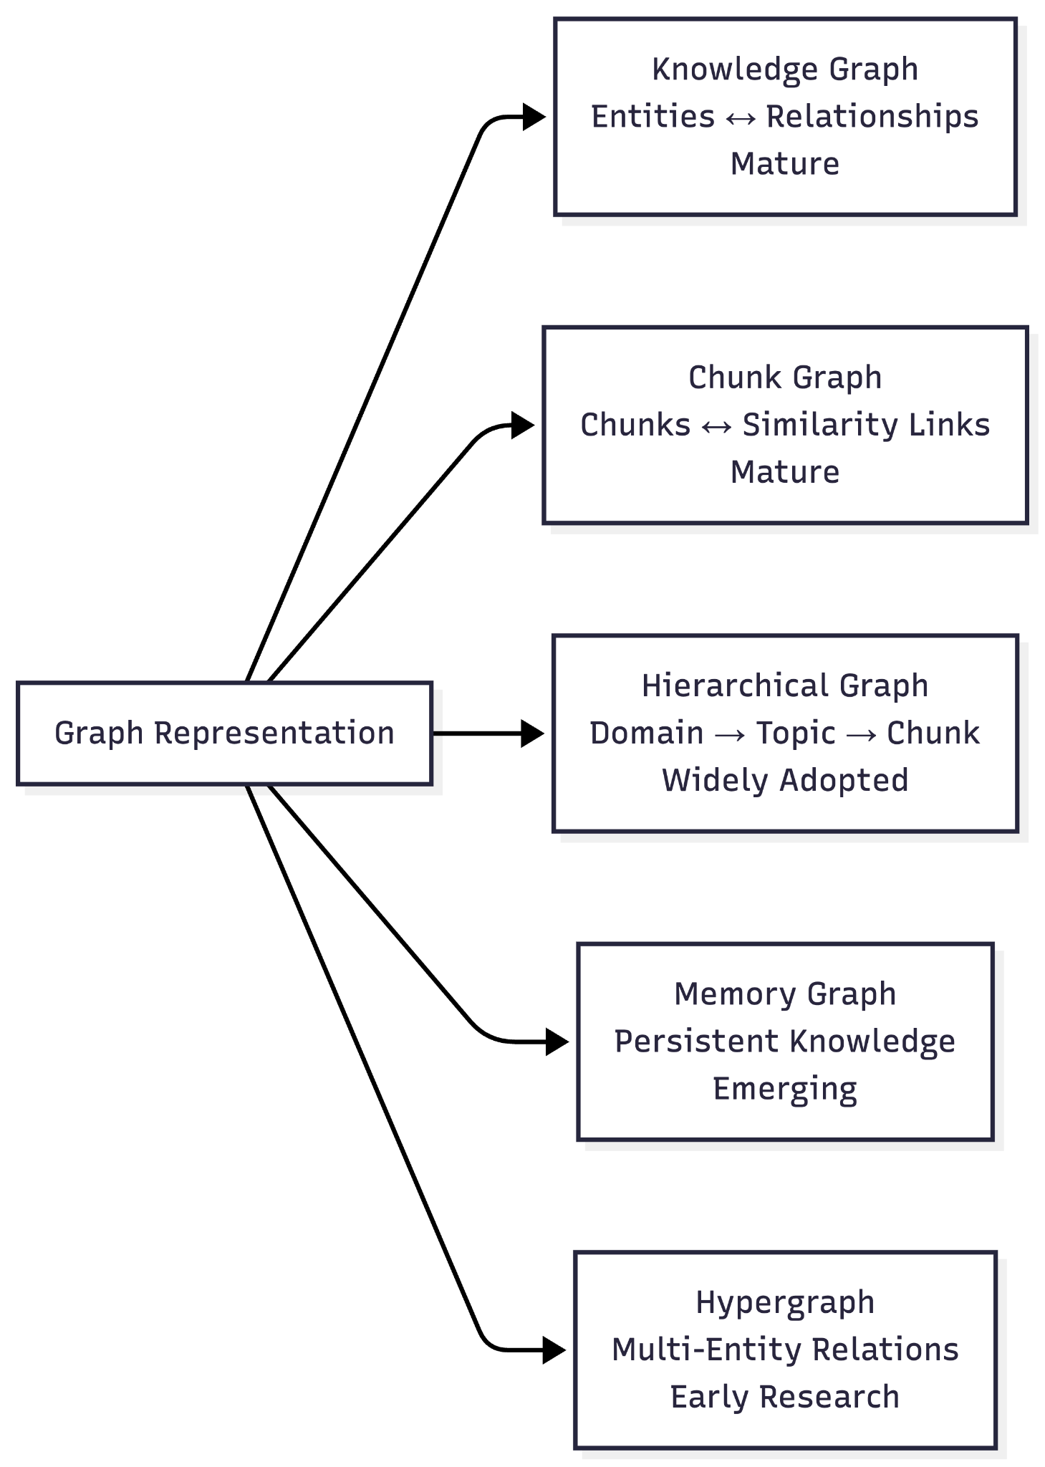
Representation | Core Idea | Strength | Weakness | Research Status
Knowledge Graph | Entities + explicit relations | Multi-hop reasoning | Expensive construction | Mature
Chunk Graph | Chunks connected by similarity | Low cost | Weak semantics | Mature
Hierarchical Graph | Multi-level abstraction | Global understanding | Complex hierarchy creation | Widely adopted
Memory Graph | Persistent knowledge structure | Personalization | Memory consistency | Emerging
Hypergraph | Higher-order relationships | Rich expressiveness | Limited tooling | Early research

Examples and Source of Graph Representation:

Representation | Representative Papers | Example Systems | Dataset Characteristics | Example Datasets / Domains | Key Contribution
Knowledge Graph | Think-on-Graph, RoG, G-Retriever | KG-RAG, KAG | Entity-rich datasets with explicit semantic relationships | Biomedical: PubMed, Enterprise Knowledge Bases: Wikidata, Product Catalogs, Legal Contracts, Financial Transactions | Explicit multi-hop reasoning over entity relationships
Chunk Graph | LightRAG, HippoRAG | LightRAG, HippoRAG | Large collections of unstructured documents with limited explicit relationships | Research papers, PDFs, Technical Documentation, Company Wikis, Manuals, Meeting Notes | Low-cost contextual bridging across semantically related chunks
Hierarchical Graph | RAPTOR, Microsoft GraphRAG | Microsoft GraphRAG | Large corpora with natural document hierarchy | Books, Annual Reports, Scientific Literature, Policy Documents, Enterprise Document Repositories | Corpus-level global understanding through hierarchical summarization
Memory Graph | MemGPT, MemoryBank, Mem0 | Mem0, A-MEM | Continuously evolving user interactions and experiences | Chat histories, AI assistant memory, CRM interactions, Customer feedback, Organizational lessons learned, Personal knowledge bases | Persistent long-term memory and personalization
Hypergraph | HGNN, HyperRAG | Research Prototypes | Multi-party relational datasets where one event involves multiple entities | Clinical trials, Insurance claims, Fraud detection, Supply chains, Legal cases, Scientific collaboration networks | Models higher-order (polyadic) relationships beyond pairwise edges

2. Graph Construction
Graph construction investigates the methodologies used to transform unstructured documents into graph structures.
The following construction approaches were examined:
- LLM-based Extraction – Uses Large Language Models to extract entities, relationships, and graph structures from text.
- NLP/OpenIE-based Construction – Employs traditional Natural Language Processing techniques such as Named Entity Recognition (NER), dependency parsing, and Open Information Extraction.
- Ontology-Driven Construction – Builds graphs based on predefined schemas, ontologies, and domain knowledge.
- Hybrid Construction Approaches – Combines LLM-based and rule-based techniques to improve graph quality and reduce cost.
- Dynamic Graph Updates – Investigates methods for maintaining and updating graphs incrementally as new information becomes available.
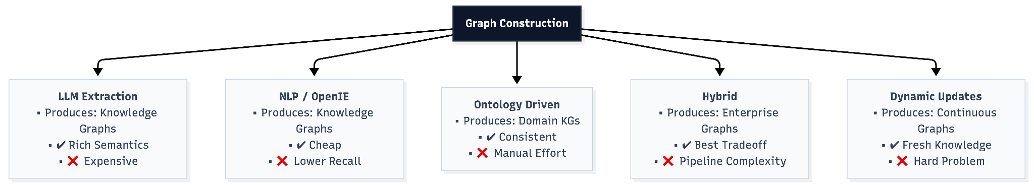

Technique | Representative Papers | Example Systems | Typical Graph Produced | Best-Suited Dataset | Trade-offs & Engineering Notes
LLM-Based Extraction (Open-ended Prompting) | Microsoft GraphRAG (2024), HyperRAG, KG-LLM | Microsoft GraphRAG | Knowledge Graph, Memory Graph | Enterprise documents, legal contracts, scientific literature, policy documents | Uses Large Language Models to extract entities, relationships, concepts, and events from unstructured text. Provides excellent semantic understanding and high recall for implicit relationships but is computationally expensive, slower at scale, and susceptible to hallucinated entities or incorrect relations without robust entity resolution and validation.
NLP / OpenIE (Open Information Extraction) | REBEL, SpERT, N-ary OpenIE | Traditional Knowledge Graph Pipelines | Knowledge Graph | News articles, Wikipedia, structured enterprise documents, large document repositories | Relies on Named Entity Recognition (NER), dependency parsing, and relation extraction to construct graphs. Highly scalable, deterministic, and inexpensive compared to LLMs, but struggles to capture implicit semantics, long-range dependencies, and complex multi-hop relationships.
Ontology / Schema-Driven Construction | Domain Knowledge Graph Literature, Biomedical KG Research | SNOMED-CT, UMLS, Enterprise Ontologies | Domain Knowledge Graph | Healthcare, biomedical literature, legal regulations, financial compliance documents | Constructs graphs using predefined schemas or ontologies. Produces highly consistent, interpretable, and deterministic graphs that are well suited for regulated domains. However, it lacks flexibility and may fail to capture novel entities or emerging relationships outside the predefined schema.
Hybrid Construction (Schema-Guided LLM / Dual-Level) | LightRAG (2024), HKGRAG | LightRAG, Enterprise GraphRAG Systems | Enterprise Knowledge Graph, Hierarchical Graph | Enterprise knowledge bases, technical documentation, research corpora | Combines LLM reasoning with rule-based extraction, entity linking, or ontologies. Currently the dominant production strategy because it balances semantic richness, extraction quality, scalability, and infrastructure cost while reducing hallucinations through structured constraints.
Dynamic & Incremental Graph Updates | A-MEM (2025), MemoryBank, Mem0 | Agentic Memory Systems, Continual GraphRAG | Memory Graph, Dynamic Knowledge Graph | Conversational AI, organizational knowledge bases, user memory, continuously evolving enterprise data | Supports continuous graph evolution through node insertion, deletion, merging, and memory consolidation without rebuilding the entire graph. Enables real-time adaptation but remains an active research area due to challenges such as graph consistency, conflict resolution, incremental summarization, and efficient maintenance of hierarchical structures.

3. Graph Retrieval
Graph retrieval focuses on identifying and extracting relevant portions of the graph in response to a user query.
The following retrieval strategies were explored:
- Node Retrieval – Retrieves individual graph nodes relevant to a query.
- Neighborhood Retrieval – Expands retrieval to include neighboring nodes and local graph context.
- Path Retrieval – Identifies reasoning paths connecting entities within the graph.
- Community Retrieval – Retrieves clusters or communities of related information, a key concept in Microsoft GraphRAG.
- Hybrid Retrieval – Combines graph retrieval with vector search and keyword-based retrieval mechanisms.
- Subgraph Retrieval – Extracts relevant graph fragments while preserving relationships among retrieved nodes.
- Agentic Retrieval – Uses iterative reasoning and retrieval loops where agents dynamically determine what information should be retrieved next.
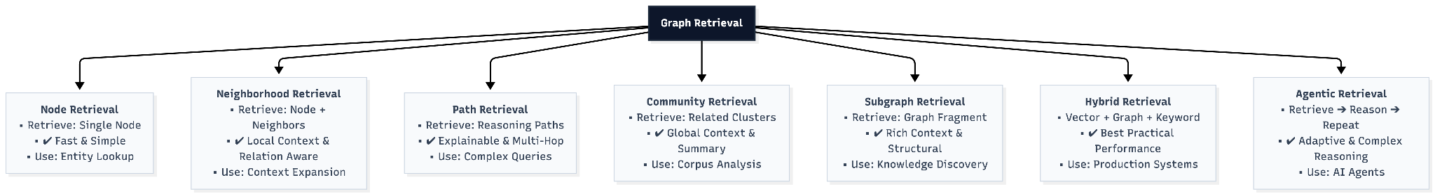

Retrieval Paradigm | Representative Papers | Example Systems | Best-Suited Query Type | Traversal Mechanics & Architectural Contribution
Node Retrieval | KG-RAG, G-Retriever | KG-RAG, KAG | Entity lookup, factual QA | Serves as the entry point for graph retrieval by identifying seed entities through entity linking, dense embeddings, or keyword matching. Efficient for fact-centric queries but limited to localized graph context.
Neighborhood Retrieval | KG-RAG, Think-on-Graph | KG-RAG | Local context expansion, entity-centric reasoning | Expands retrieval from seed nodes to their immediate neighbors (1-hop or k-hop), capturing related entities and relationships. Improves contextual completeness while maintaining computational efficiency.
Path Retrieval | PathRAG (2025), RoG | PathRAG | Multi-hop reasoning, explainable QA | Traverses explicit reasoning paths connecting entities across multiple hops. Modern approaches employ path-ranking and pruning strategies to eliminate redundant edges, improving reasoning quality, explainability, and token efficiency.
Community Retrieval | Microsoft GraphRAG (2024) | Microsoft GraphRAG | Corpus-level summarization, thematic exploration | Retrieves pre-computed graph communities generated through clustering algorithms. Community summaries enable global reasoning across large document collections and support high-level thematic questions using a Map-Reduce style inference pipeline.
Subgraph Retrieval | G-Retriever (2024), SubgraphRAG | G-Retriever | Complex analytical queries, explainable reasoning | Extracts an induced subgraph surrounding relevant entities while preserving structural relationships. Optimization techniques such as Steiner Tree variants help maximize relevant context while minimizing graph size.
Hybrid Retrieval | LightRAG (2024), HKGRAG | LightRAG | Enterprise search, production RAG | Combines vector search, graph traversal, and keyword retrieval within a unified pipeline. Balances semantic similarity with structural reasoning, making it one of the most practical retrieval strategies for production GraphRAG systems.
Agentic Retrieval | A-MEM (2025), Agentic GraphRAG, Memory-Augmented Agent literature | Agentic GraphRAG | Open-ended reasoning, adaptive planning | Employs LLM agents to iteratively plan retrieval actions, dynamically selecting nodes, paths, or communities based on intermediate reasoning. Enables adaptive graph exploration but introduces higher computational cost and orchestration complexity.

4. Graph-Augmented Generation
Graph-Augmented Generation examines how retrieved graph information is incorporated into the reasoning and response generation process.
The following areas were investigated:
- Context Assembly – Transforming retrieved graph structures into LLM-consumable context.
- Graph-Aware Prompting – Leveraging graph structure explicitly within prompts.
- Community Summarization – Generating summaries of graph communities and clusters for global reasoning.
- Graph-Native Reasoning – Exploring reasoning approaches that directly operate on graph structures rather than flattened textual representations.
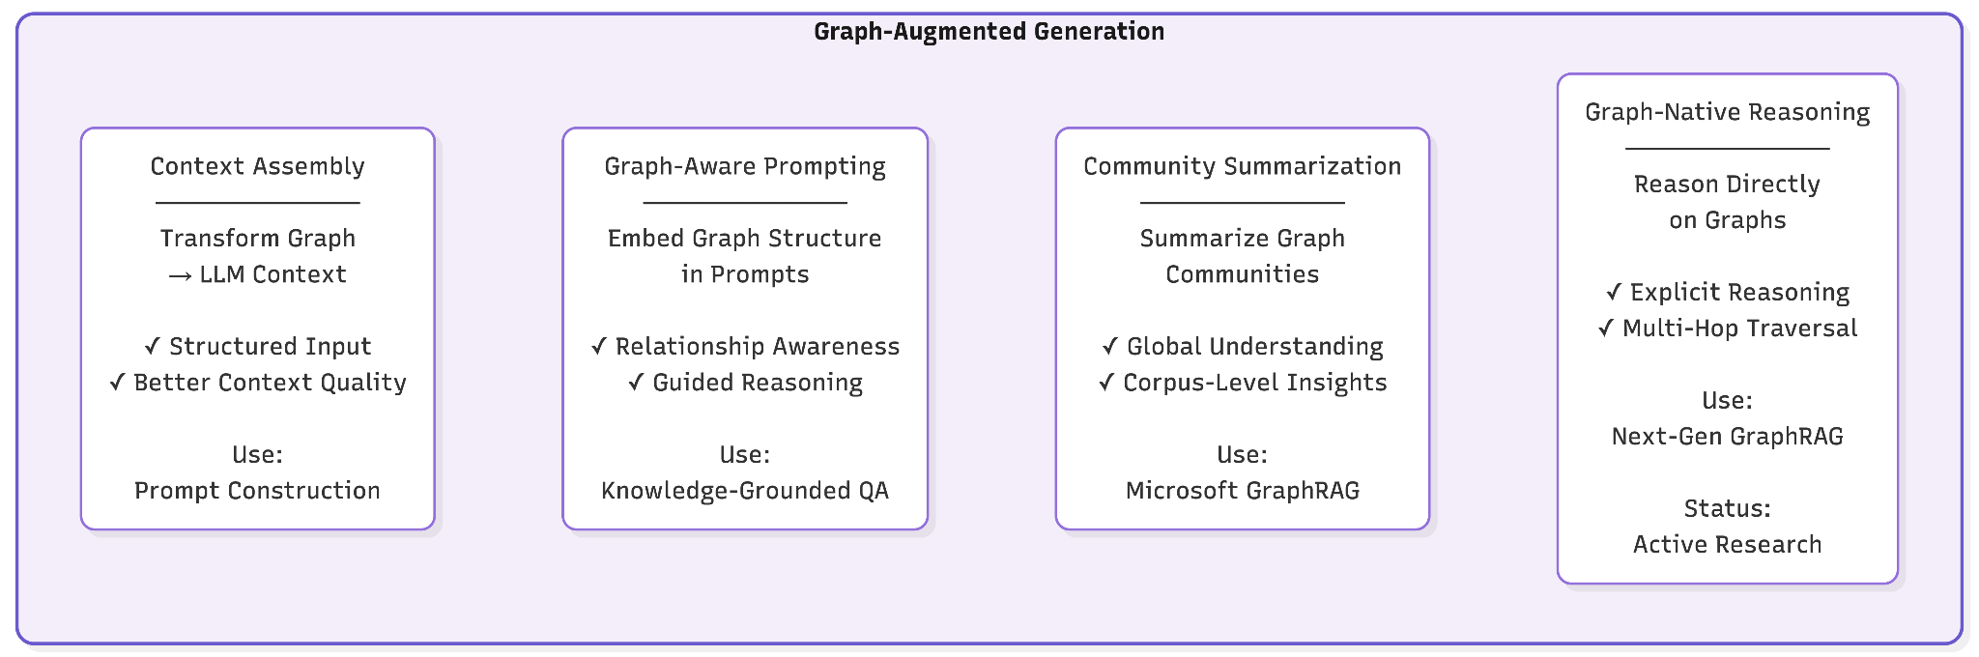

Generation Technique | Representative Papers | Example Systems | Best-Suited Task | Generation Mechanism & Engineering Trade-offs
Linearized Context Assembly | KAPING (2023), KG-RAG | Standard GraphRAG Pipelines | Fact-centric QA, entity retrieval | Mechanism: Converts retrieved graph structures (nodes, edges, paths, triplets) into linear textual context before passing them to the LLM. Trade-off: Simple, efficient, and compatible with existing LLMs, but loses graph topology and higher-order structural information as graph complexity increases.
Graph-Aware Prompting (Dual-View Prompting) | GRAG (2025), HiRAG | Advanced Long-Context RAG | Multi-hop reasoning, relationship-intensive QA | Mechanism: Presents both textual evidence and explicit graph structures (entity lists, paths, adjacency trees, or relationship tables) within the prompt. Trade-off: Preserves structural information and improves reasoning accuracy, but increases prompt complexity and token consumption.
Map-Reduce Community Aggregation | Microsoft GraphRAG (2024), DRIFT | Microsoft GraphRAG | Corpus summarization, thematic analysis, enterprise search | Mechanism: Performs parallel generation over multiple community summaries (Map stage), followed by synthesis into a unified answer (Reduce stage). Trade-off: Excellent for corpus-level reasoning and large document collections but incurs higher latency and token usage than single-pass generation.
Graph-Native Agentic Reasoning | Think-on-Graph (2024), RoG (2024) | Agentic GraphRAG, Research Prototypes | Complex planning, explainable multi-hop reasoning | Mechanism: Rather than consuming a fixed prompt, the LLM acts as an active reasoning agent that iteratively decides which nodes or edges to explore next. Trade-off: Produces highly interpretable reasoning trajectories and adaptive graph exploration, but requires multiple retrieval-generation iterations, increasing execution time and orchestration complexity.

Research Focus Areas
The survey revealed that current GraphRAG research activity is concentrated primarily within Graph Construction and Graph Retrieval. In particular, significant attention is being directed toward:
- LLM-based versus traditional NLP-based graph construction techniques.
- Dynamic and incremental graph maintenance.
- Hybrid retrieval architectures that combine graph and vector search.
- Agentic retrieval systems capable of iterative graph exploration.
- Emerging graph structures such as memory graphs and hypergraphs.
- Adaptive reasoning architectures that construct or modify graph structures dynamically at query time.
This taxonomy provides a structured framework for analyzing existing GraphRAG systems and serves as the foundation for deeper exploration of graph construction techniques, retrieval strategies, and emerging research directions in subsequent phases of the study.

Datasets:

Domain | Dataset | Experimental Role | Dataset Characteristics (Why This Dataset?) | Recommended Representation | Recommended Retrieval
Financial | FinQA | Primary | Financial reports combine narrative text, structured tables, numerical values, and cross-references. Answering questions requires integrating evidence across multiple report sections rather than retrieving a single passage. | Knowledge Graph + Hierarchical Graph | Path + Community Retrieval
Financial | FiNER-139 | Validation | Contains expert-annotated financial entities such as companies, securities, monetary values, and financial instruments with minimal reasoning complexity. | Knowledge Graph | Node + Neighborhood Retrieval
Healthcare | MIMIC-IV | Primary | Clinical records naturally contain interconnected patients, diagnoses, medications, laboratory results, procedures, and timestamps. Clinical decisions require reasoning across multiple related events. | Knowledge Graph + Hypergraph | Path + Subgraph Retrieval
Healthcare | PubMedQA | Validation | Biomedical research articles contain highly technical terminology, long documents, and conceptually related studies requiring both factual retrieval and thematic understanding. | Knowledge Graph + Hierarchical Graph | Community + Hybrid Retrieval
Legal | CUAD | Primary | Contracts exhibit deep hierarchical organization (Agreement → Article → Clause → Sub-clause) together with explicit legal entities, obligations, and dependencies. Many queries depend on both structural context and semantic relationships. | Knowledge Graph + Hierarchical Graph | Path + Hybrid Retrieval
Legal | CaseHOLD | Validation | Judicial opinions reference statutes, precedents, and prior court decisions through dense citation networks spanning multiple documents. Legal reasoning often requires following chains of precedent rather than isolated passages. | Knowledge Graph + Hierarchical Graph | Path + Community Retrieval

